How To Reset Jenkins Default Port :

*Create an Amazon Linux Server then install Jenkins and required Plugging’s below are the detailed commands to install Jenkins.

**Step-1**

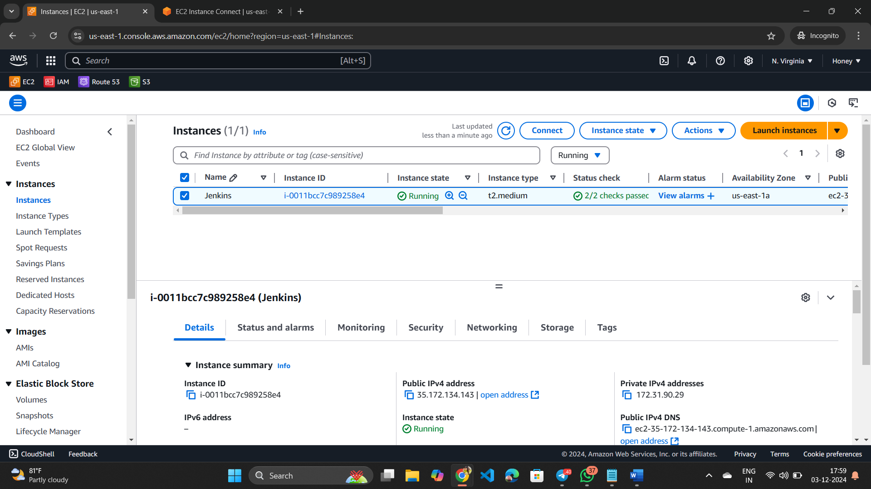

**Step-2 --- Installation process**

*sudo yum update -y

*sudo yum install git -y

*sudo dnf install java-17-amazon-corretto -y

*sudo wget -O /etc/yum.repos.d/jenkins.repo https://pkg.jenkins.io/redhat-stable/jenkins.repo

*sudo rpm --import https://pkg.jenkins.io/redhat-stable/jenkins.io-2023.key

*sudo yum install jenkins -y

*sudo systemctl enable jenkins

*sudo systemctl start jenkins

*sudo systemctl status jenkins

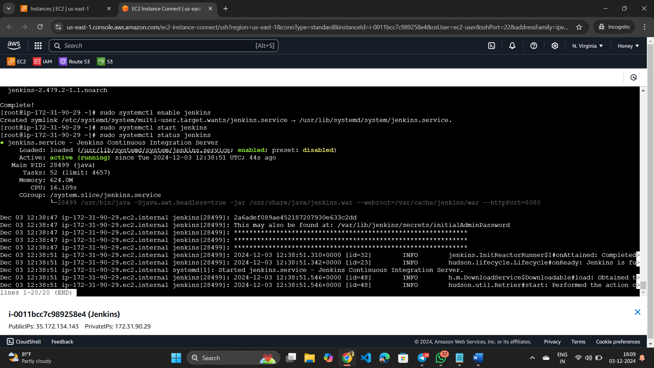

*Copy your server ---public ip---- 35.172.134.143

*Add Jenkins default port number to your public ip like 35.172.134.143:8080

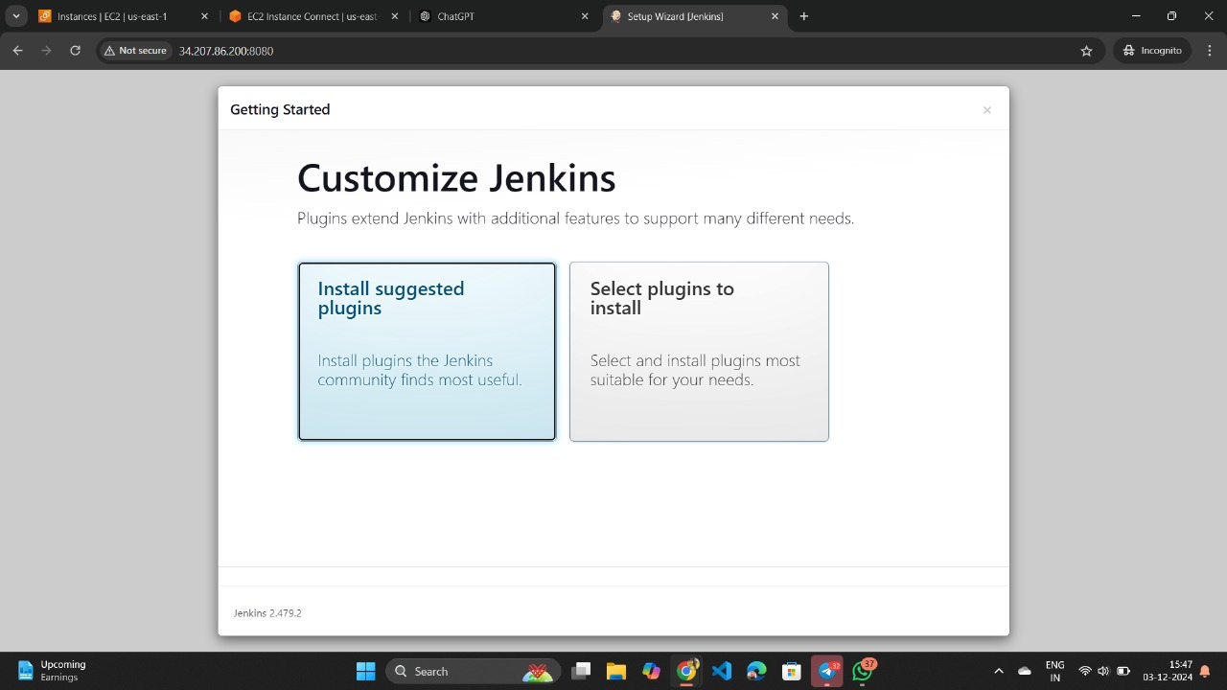

*Then add admin user details

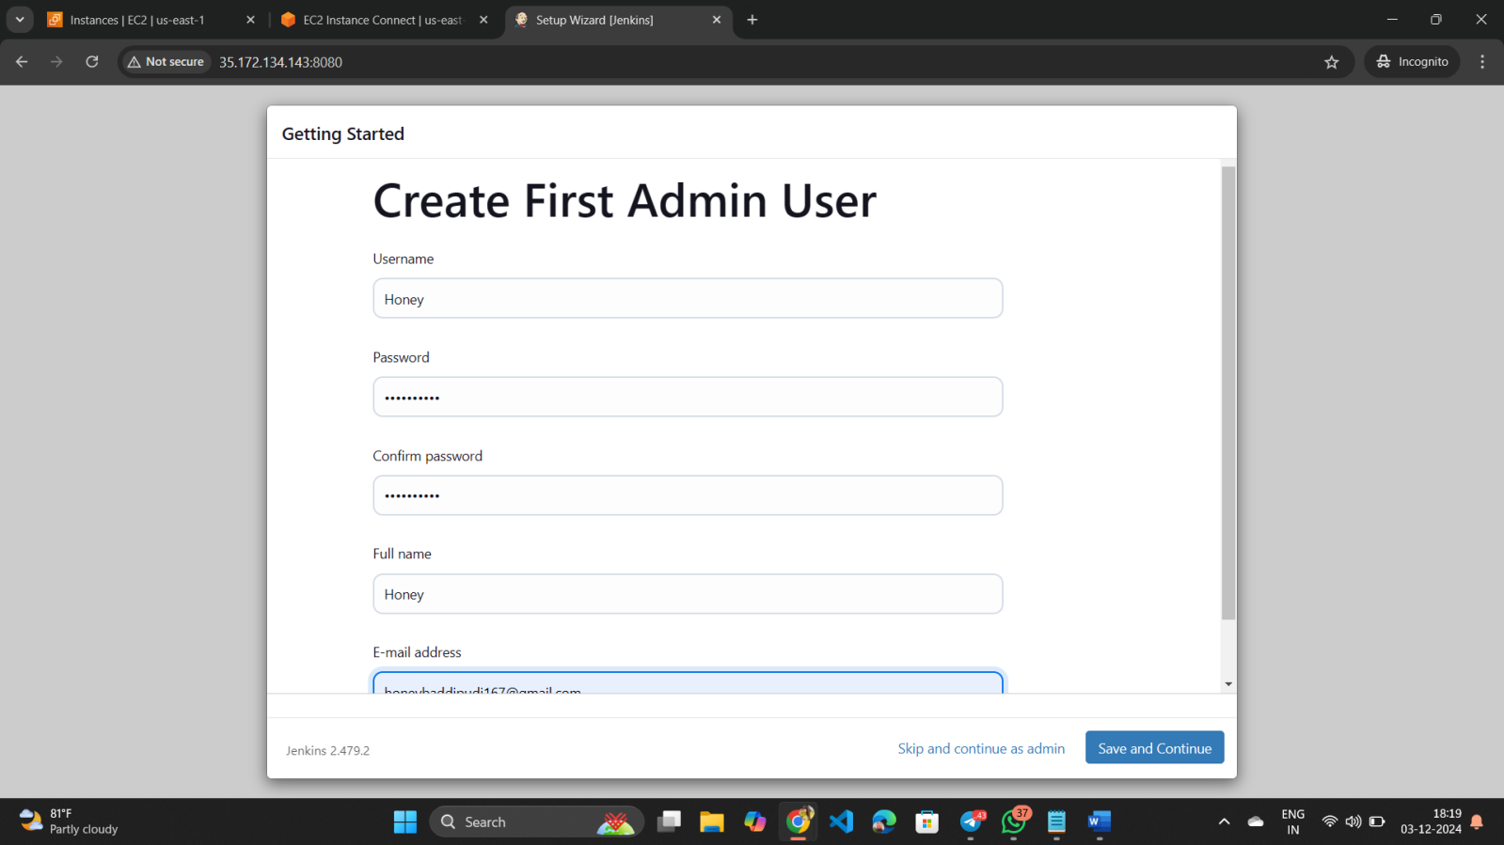

*Jenkins url configuration -------click on save and finish

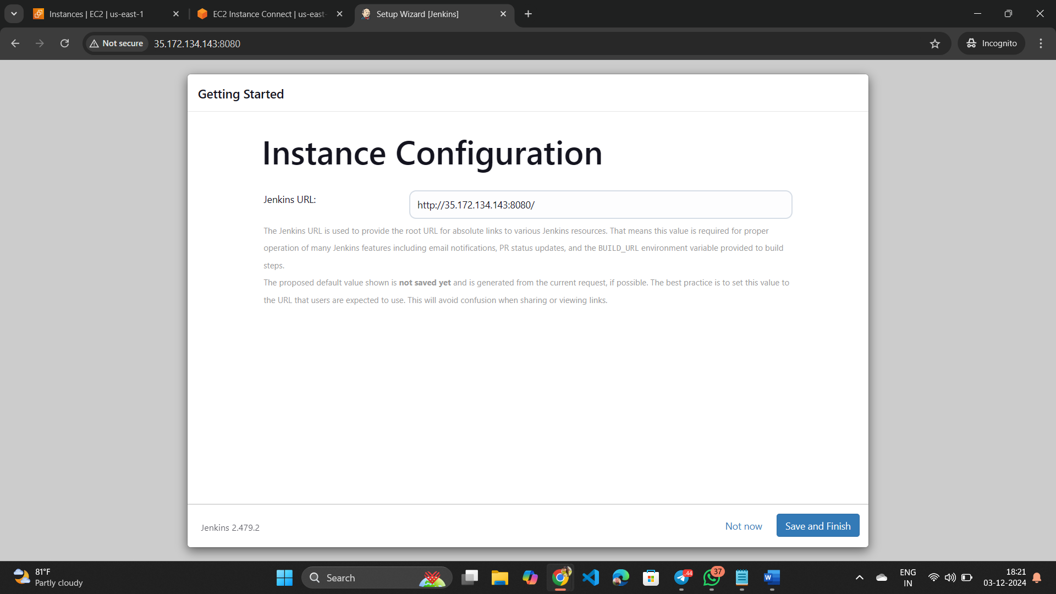

*Click on start using Jenkins

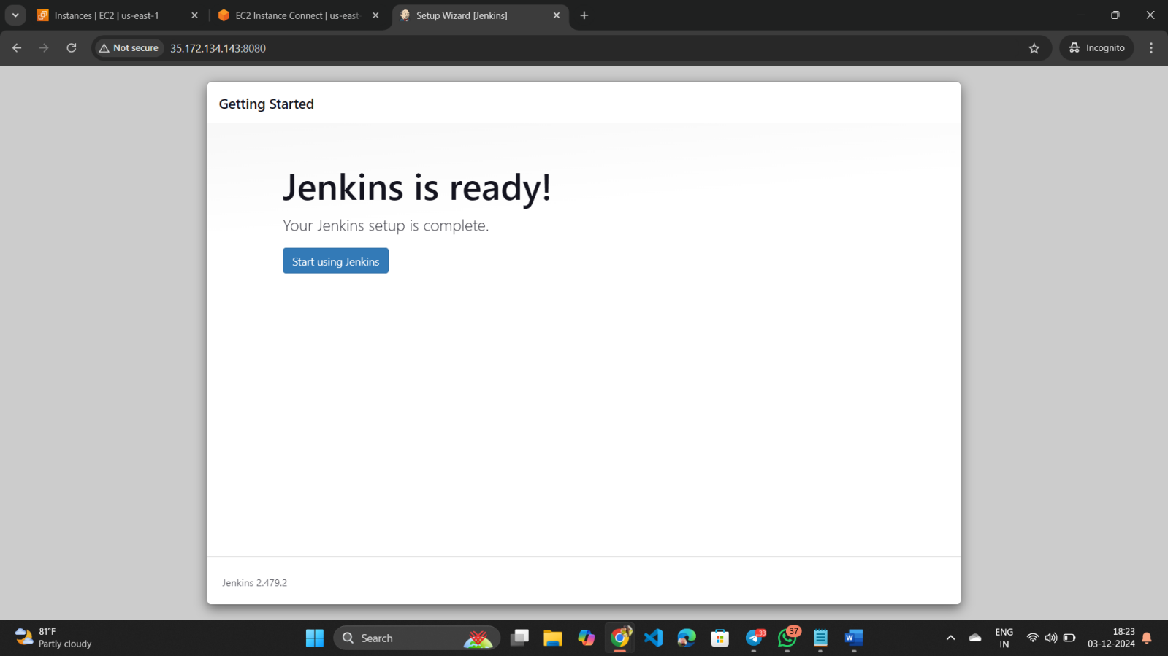

*Click on new item

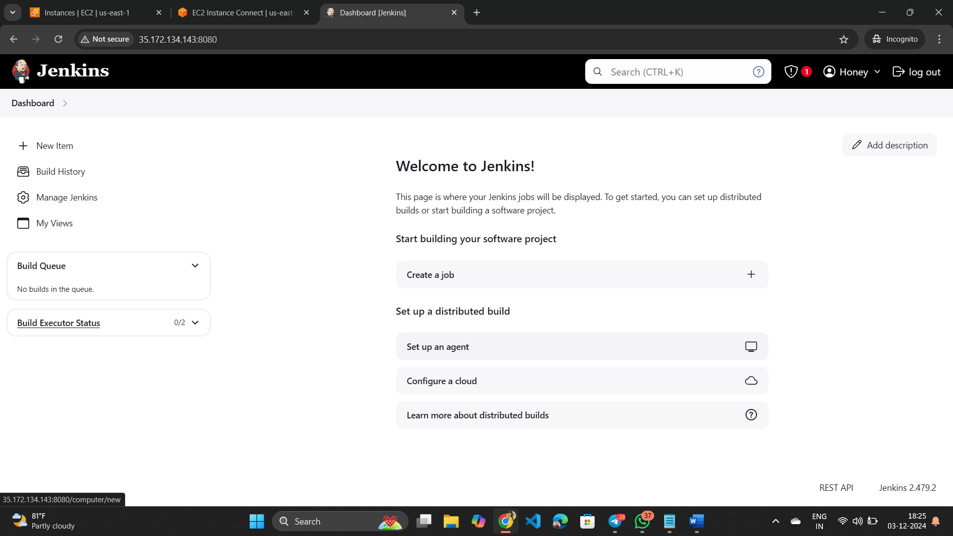

*Give an item name and select pipeline then click on Ok

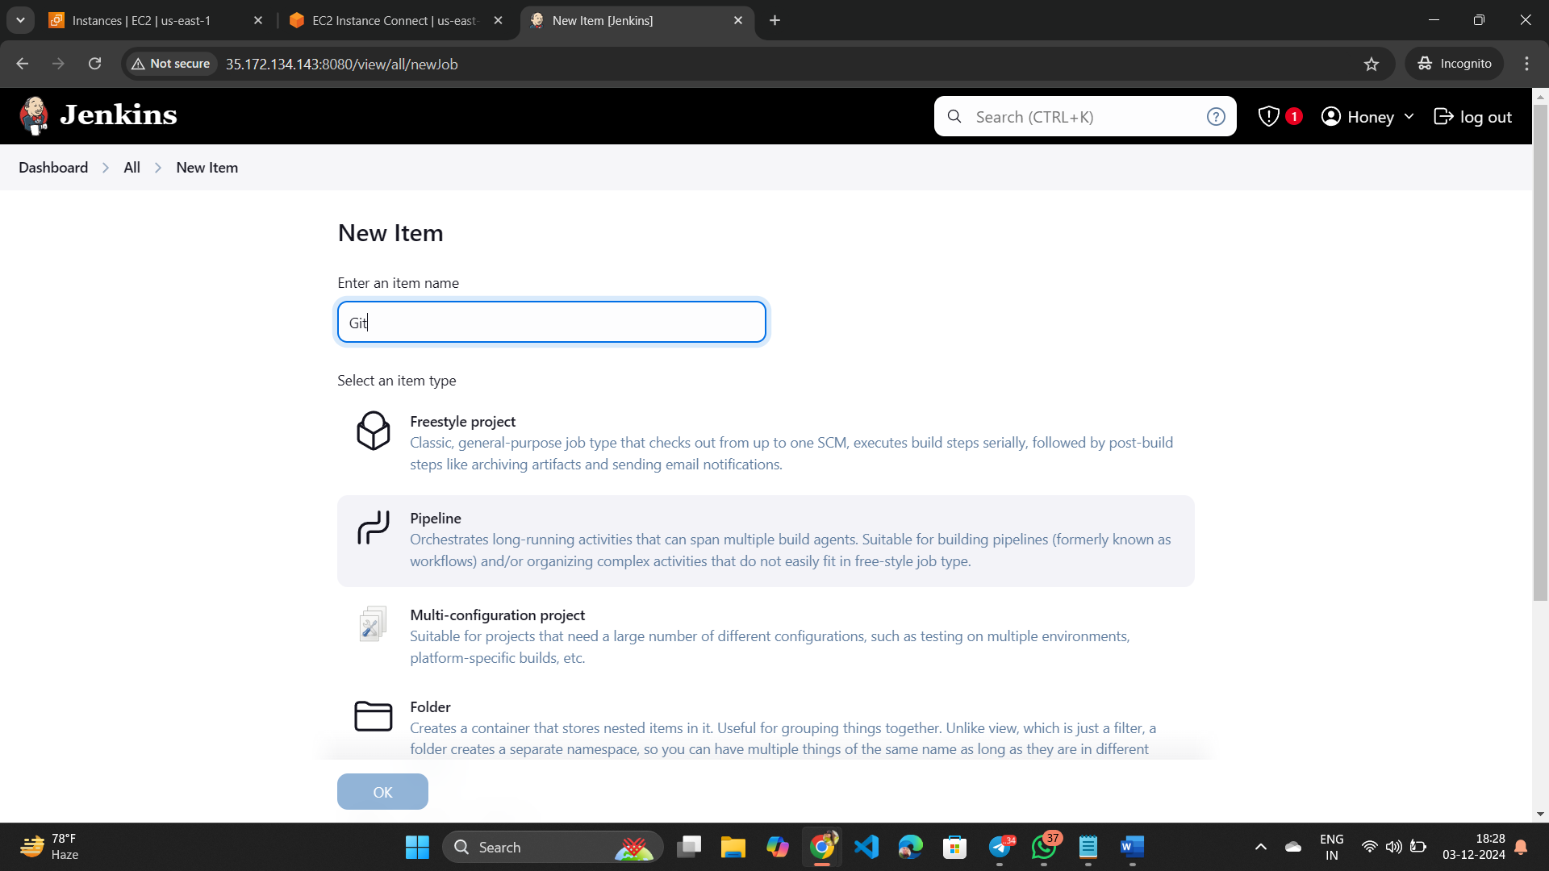

*Click on try sample pipeline under Hello World then click on apply and save.

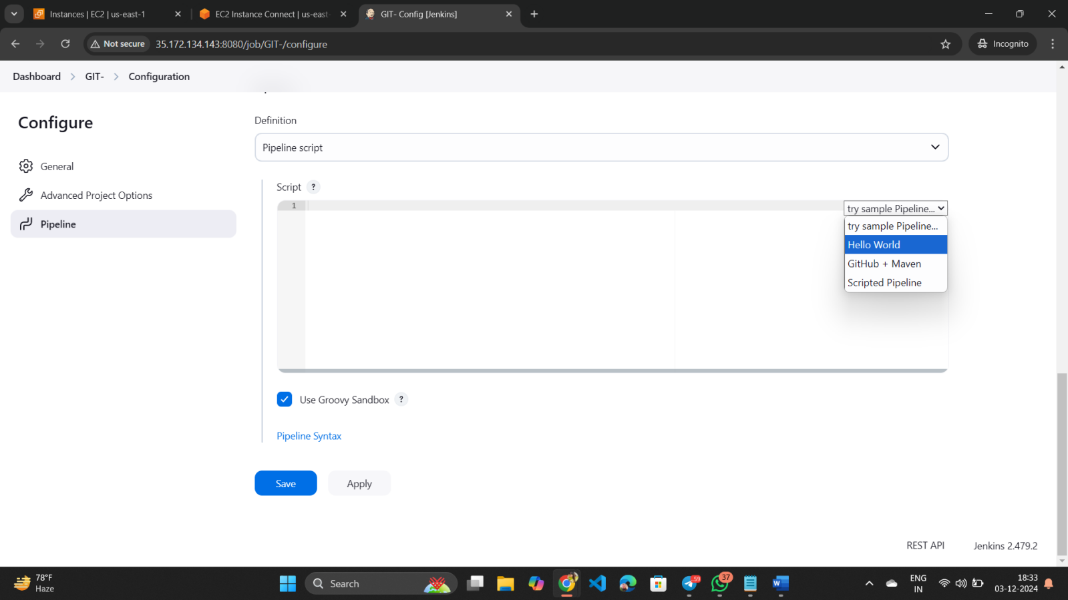

*Then click on Build Now

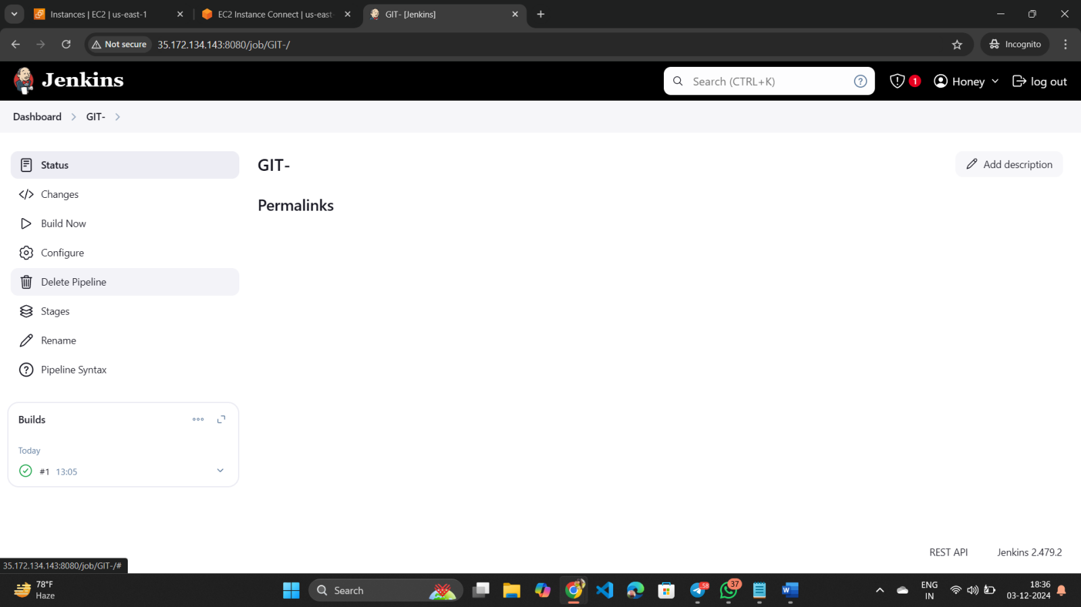

*The output is not coming right? Because the required plugins are missing. We need to install them. To do that please go one step back.

*Click on manage Jenkins

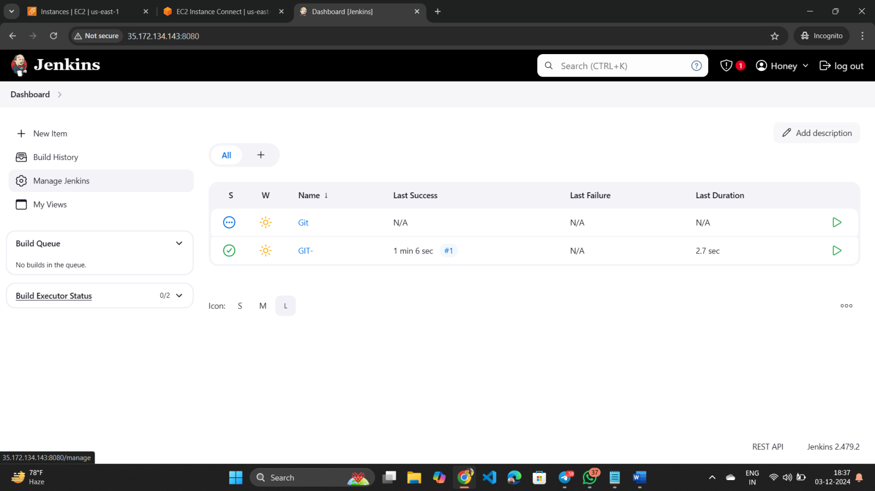

*Then click on pluggings

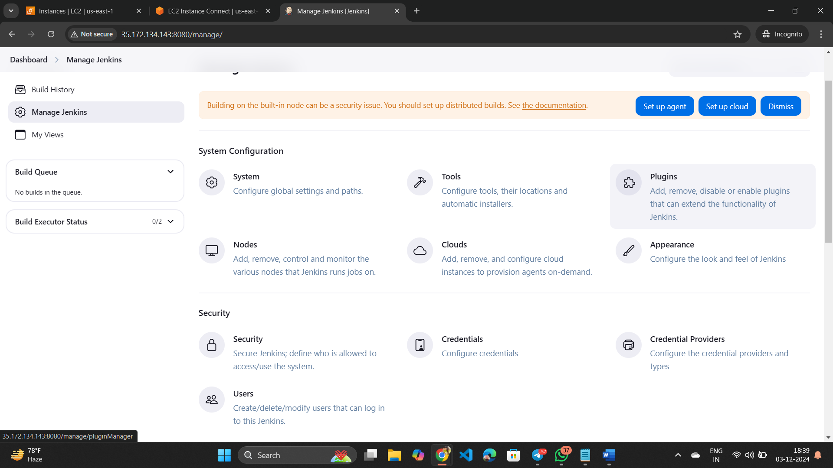

*After that click on available plugins,select pipeline stage view,and install it.

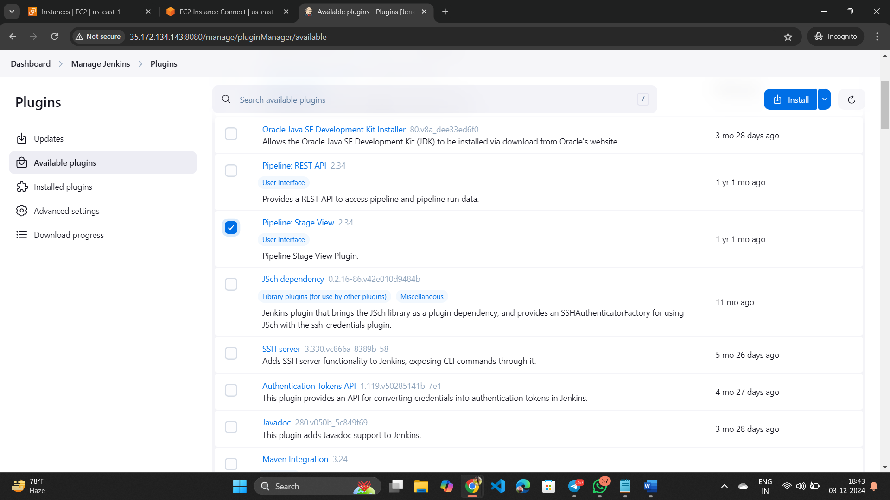

*Then click on go back

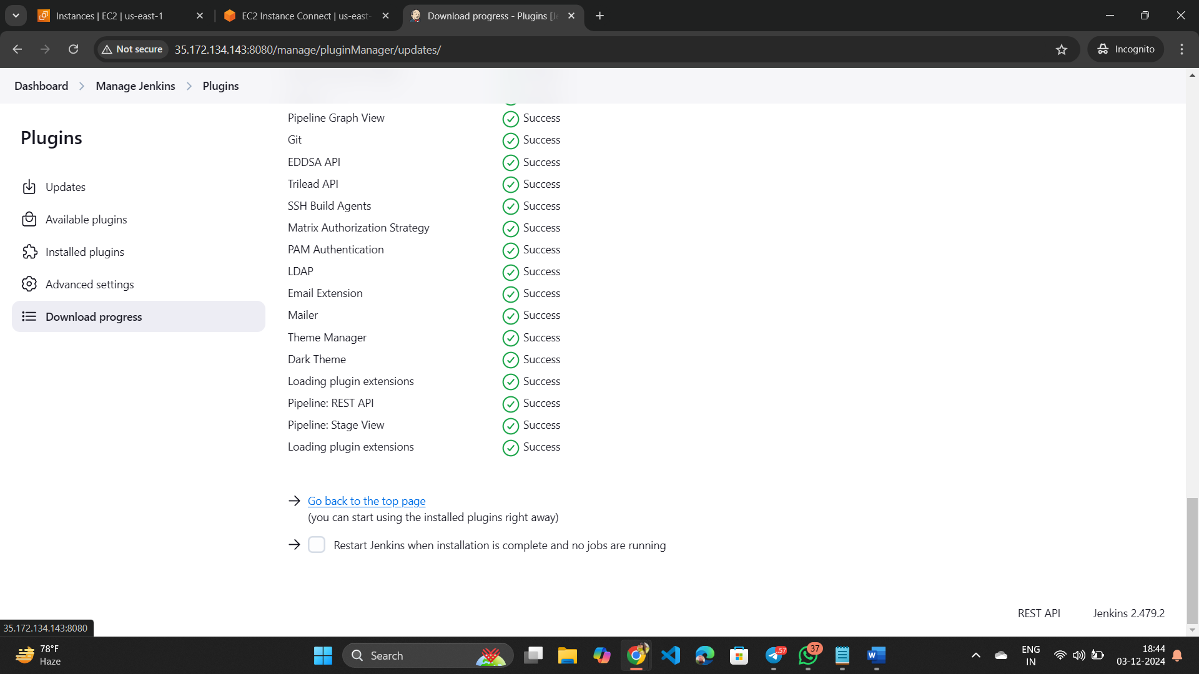

*After that click on your item name and you will be able to see the code output

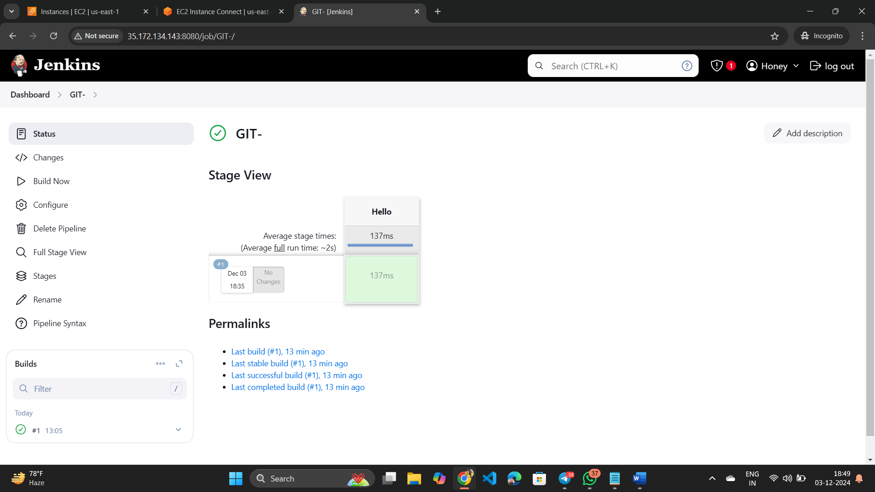

*Now come back to our server because we need to change the Jenkins port

*Run this command on your server -------

sudo vi /usr/lib/systemd/system/jenkins.service

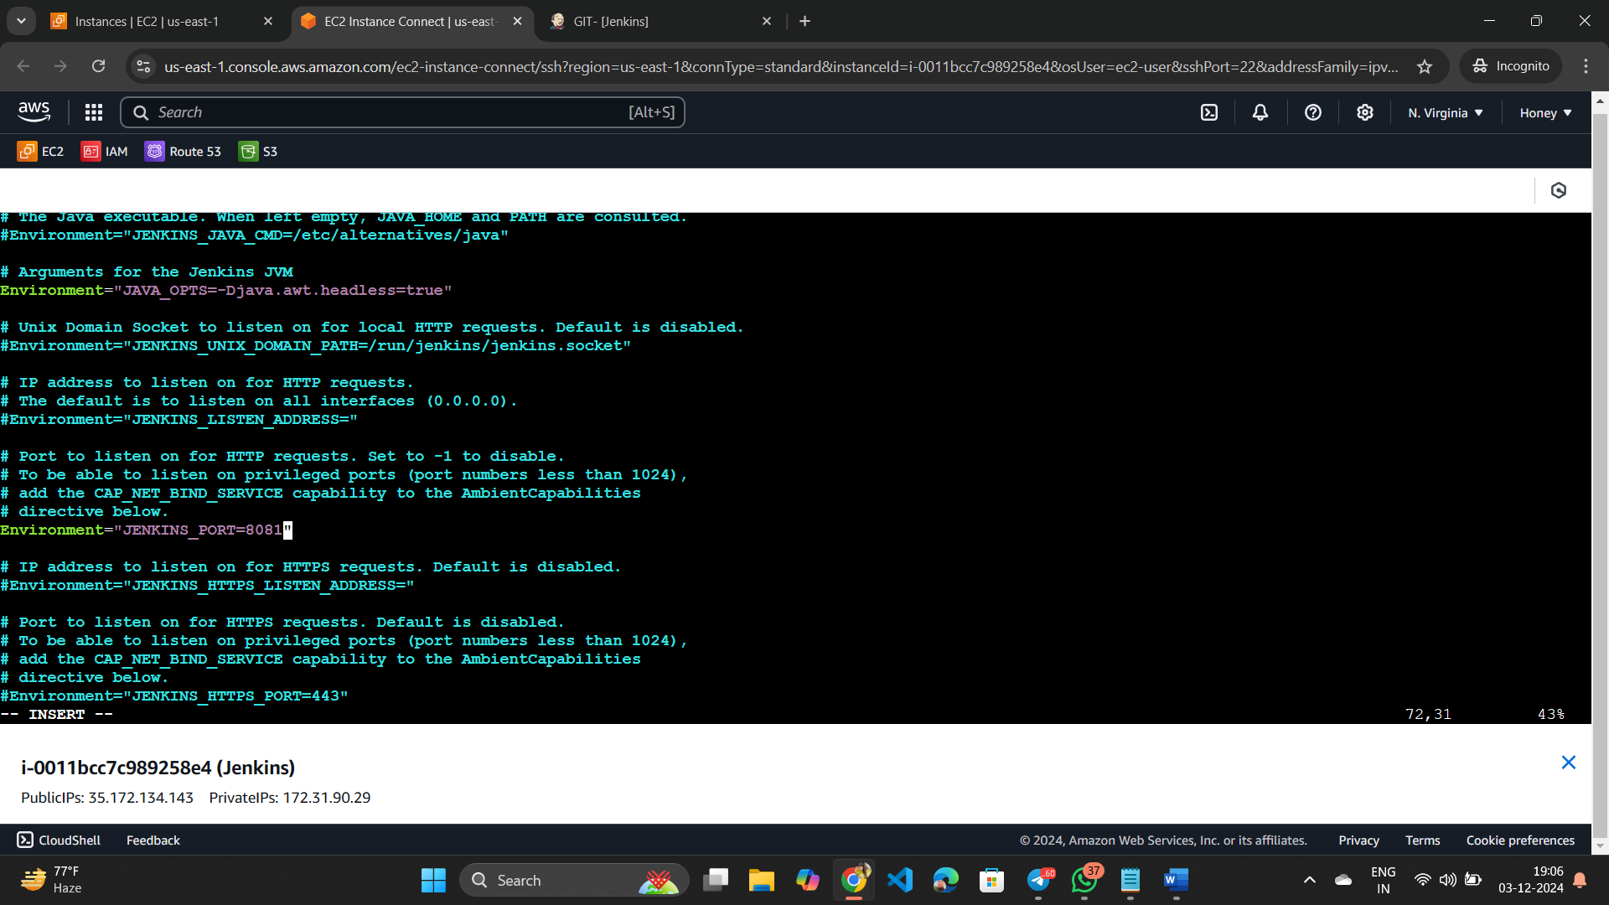

*Edit the environment and provide the port number you want to assign then save it.

*And re-start it ------------- systemctl restart jenkins.service

*Then Run 'systemctl daemon-reload' to reload units

*After that restart jenkins ------------- sudo systemctl restart Jenkins

Restarting after reload the Jenkins page - it won’t open the previous port number 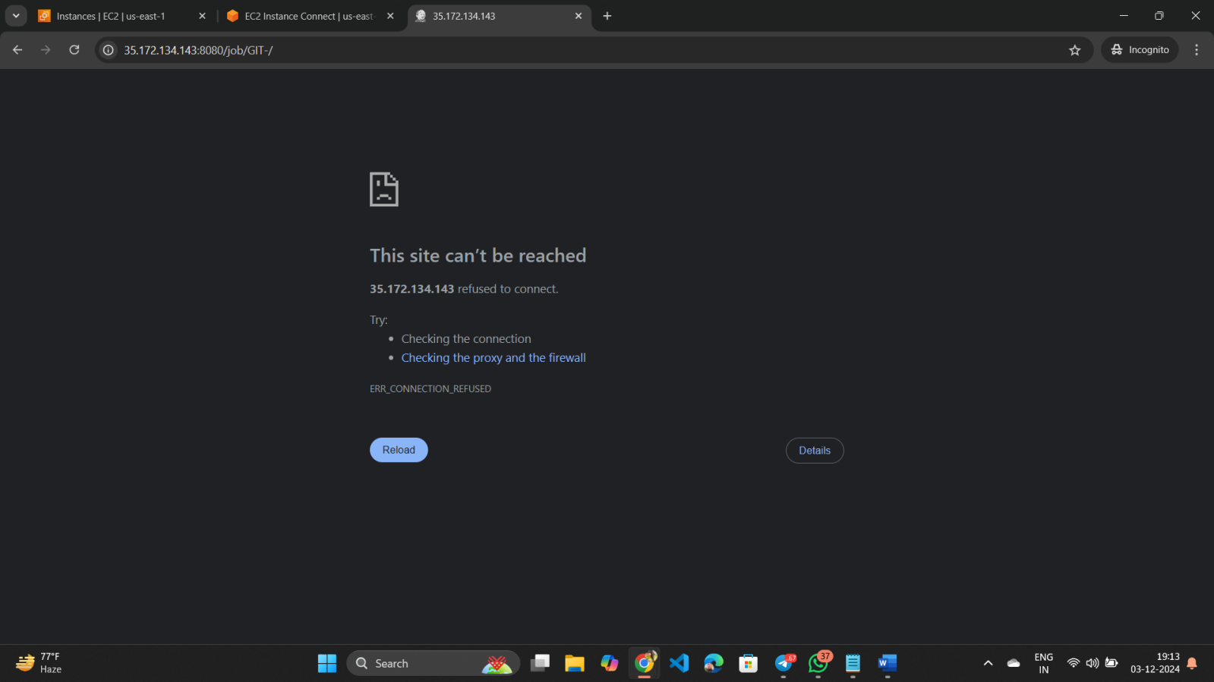

*Now change the port number and enter it. You will be able to see the Jenkins page.

